**Not tried but according to video shown in the mentioned file**

1. First of all jdk must be installed on our machine before we install apache-tomcat
2. The we download the binary from the website <http://tomcat.apache.org/>
3. Copy this binary to our local machine.
4. Untar or unzip the file apache-tomcat-8.0.18.tar.gz (version can be any)
5. We will receive the folder as apache-tomcat-8.0.18
6. As there are various tools under apache like apache-ant , tomcat etc. we can create a group named apache and place all the things in it.
7. So we are creating a group apache in /usr/apache
8. Copy the utarred folder apache-tomcat-8.0.18 in this apache folder.
9. Now we have our tomacat in path as:

**/usr/apache/ apache-tomcat-8.0.18**

This is our path for **CATALINA_HOME** because we have to configure this tomcat. This variable is the environment variable.

1. Now we have to configure the environment variable **$CATALINA_HOME**

Open the file **/etc/profile**

export CATALINA_HOME=/usr/apache/ apache-tomcat-8.0.18

:

1. Now we have configured the file so we need to restart the server or we can give the command as:

**source /etc/profile**

we can check if the configurations have been done or not by echo **$CATALINA_HOME**

1. Then go to the directory bin
2. Set the execute permissions for every file.
3. Start the service by executing ./startup.sh
4. Now we can open the browser and give the path as:

[http://localhost:8080](http://localhost:8080/)

tomcat will open

go to manage apps

it will ask for user name and password but we do not have username and password right now so we do cancel and a error page will be displayed as:

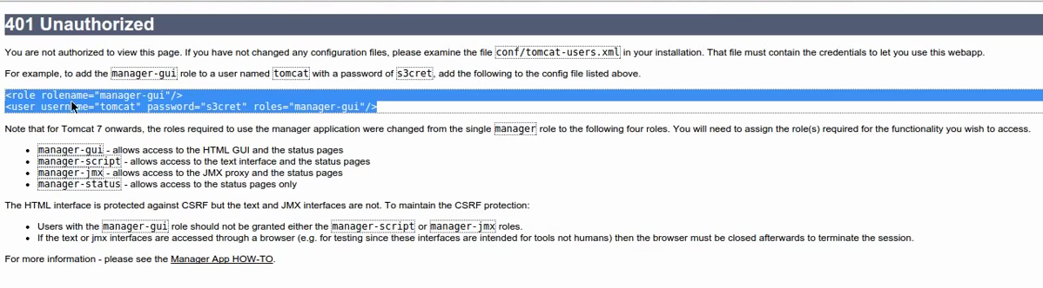

Copy the highlighted part and open the file

/usr/apache**/ apache-tomcat-8.0.18/conf/tomcat-user.xml**

**Paste the copied part here**

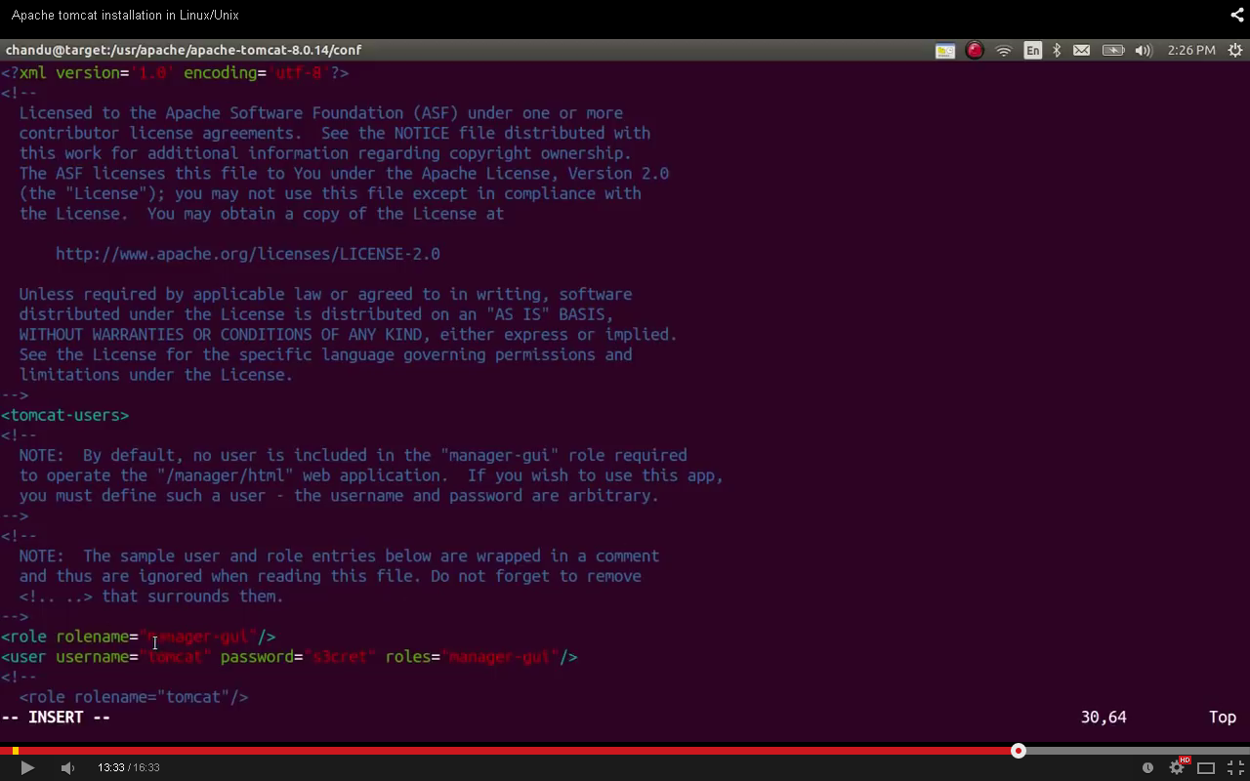

We can change the username and password according to us.

1. Now run the shutdown script
2. Then again run the startup script
3. Open the browser again and we can deploy our war files.